**Research Position Final Report**



|  |  |
| --- | --- |
| Work Term Period | June – August 2017 |
| Research Assistant | Faraz Sadrzadeh-Afsharazar |
| Project Supervisor | Dr. Alexandre (Sasha) Douplik |
| Department | Physics |
| Project Titles | Standalone 685nm Laser Modules  Multi-Wavelength Laser Light Source |

**Table of Contents**

***I.* First Project: Multiwavelength Laser Source 3***I-a.* Introduction 3  
*I-b.* Current Setup x  
*I-c.* Electronic and Hardware Advancements x  
 *I-c-a.* Power Supply Design – Pre-regulation x  
 *I-c-b.*  Power Supply Design – Post-regulation x  
 *I-c-c.* Laser Drivers x  
 *I-c-d.* Laser Power Control x  
 *I-c-e.* Laser Current Monitoring x  
 *I-c-f.* Chassis Design x  
*I-d.* Graphical User Interface x  
 *I-d-a.* Front Panel Controls x  
 *I-d-b.* Software-Hardware Intervention x  
*I-e.* Challenges Faced and Future Works x  
*I-f.* References x  
*I-g.* Appendix x  
 *I-g-a.* CAD Models x  
 *I-g-b.* Electrical Schematics x  
 *I-g-c.* Microcontroller Embedded Code x

***II.* Second Project: Standalone 685nm Laser Modules***II-a.* Introduction x  
*II-b.* Hardware Design x  
 *II-b-a.* Component Selection and Electrical Design x  
 *II-b-b.* Unit Assembly and Fabrication x  
*II-c.* Conclusion x  
*II-d.* References x  
*II-c.* Appendix x

***III.* Acknowledgements**

**I. First Project: Multiwavelength Laser Light Source**

**I-a. Introduction**

The objective of the project is to employ eight laser diodes of varying wavelengths and develop a multi-wavelength laser source (MWLS). The lasers are first required to be coupled into a liquid light guide and be delivered to a target specimen. In this context, the term coupling refers to the act of shining a laser(s) into an optical fiber, with the goal of having minimal losses, as the beam propagates through and leaves an optical fiber. The objectives for achieving this include designing respective laser drivers for the eight intended laser diodes, designing the required optics to collimate the output of each laser diode into a coherent pencil beam and couple the beams into a liquid light geode, and securely integrate both the designed optical and electronic compartments into a chassis. The desired laser output is needed to be Gaussian and the output wavelengths should be homogenously mixed. This requires the precise alignment of all laser beams such that the beams enter the fiber at an angle, significantly lower than the acceptance angle of the fiber. Although the multi-mode fiber that is used has large optical input aperture of Ø6.2 mm, a slight misalignment of the laser beams at input causes a ring shaped (fringed) illumination at the light guide’s exiting point.

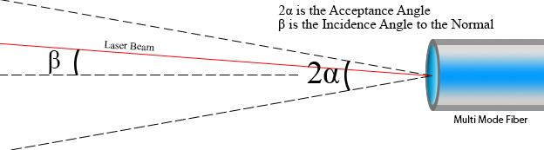

Fig. 1. How the Laser Beam Should Enter the Fiber, Where β << α

As illustrated in Fig. 1, the incident beam must pinpoint the center of the multimode fiber. Additionally, the incidence angle β must be smaller than acceptance angle α; as β reaches zero, the output illumination approaches the desired distribution, thus β must thus be minimized. It is speculated that the addition of a beam homogenizer at the entrance or exiting point of the fiber would solve this problem. All these restrictions are defined by a fiber’s Numerical Aperture. This number can be used to calculate the maximum incidence angle that a light beam can enter a fiber (acceptance angle), without having major power losses, as it propagates through the fiber. This power loss can be prevented by ensuring that the propagating beam performs total internal reflection throughout. Fig. 2. Demonstrates this concept [1], [2].

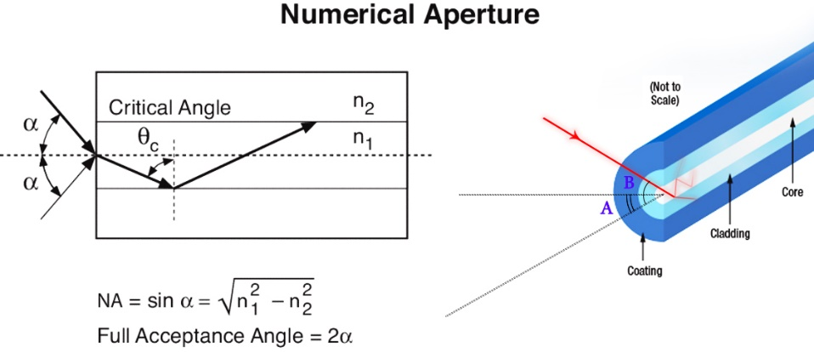

Fig. 2. The Equation Behind Numerical Aperture and How a Beam Loses Power if Its Incidence Exceeds the Acceptance Angle. Retrieved and Modified from [1], [2]

In order to measure such a parameter, the behavior of light should be studied when it’s leaving the end of the fiber. In this project, a liquid light guide is being used that is supposed to carry the modes of all of the lasers, with various wavelengths. A liquid light guide is an optical fiber with an exceptionally large core, which can carry many modes of internal reflection. To measure the acceptance angle of the liquid light guide that we are using, white light was shone at one end of the fiber and the projection of the light leaving the other end was observed on a parallel plane. Using a protractor, various angles were measured. As seen in Fig. 3., most of the light projection is concentrated within the angular window C. Due to the reversible nature of optical fibers, any beam light that has an equal or smaller incidence angle to the fibers entrance, should theoretically get coupled with low power losses. Further experimentation revealed that incidence double-angles of 3o or smaller would result in lower power losses. Ideally, a beam that perpendicularly enters a fiber, would have the highest coupling efficiency. Coupling efficiency can be formulated as the percentage ratio between the laser power (irradiance [W/m2]) going into the fiber over the laser power coming out of the fiber. This is illustrated in Equation 1. The beam power can be measured at both ends of the fiber, using an optical power meter such as PM160 from Thorlabs.

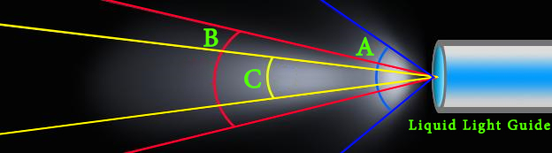

Fig. 3. Measured Fiber Acceptance Angles:  A = 35o   B = 20o   C = 15o

Equation. 1. Coupling Efficiency

In this project, we aimed to select lasers with wavelengths that spanned from the near-infrared wavelengths and ended with a wavelength that was at the higher energy end of the visible spectrum. The following table outlines the wavelengths and characteristics of the lasers diodes that were chosen. The selected diodes span wavelengths of 405 nm to 1064 nm.

Table 1. List of Laser Diodes Being Used (The Laser Drivers are Reconfigurable to Accept Other Laser Diodes)

|  |  |  |  |  |
| --- | --- | --- | --- | --- |
| Part # + Links | Wavelength (nm) | | | Package (mm) |
| **Min.** | **Typ.** | **Max.** |  |
| [DL-5146-101S](http://www.roithner-laser.com/datasheets/ld_div/dl-5146-101s.pdf) | - | 405 | - | 5.6 |
| [LD-515-10MG](http://www.roithner-laser.com/datasheets/ld_div/ld-515-10mg.pdf) | 510 | 515 | 530 | 5.6 |
| [S6430MG](http://www.roithner-laser.com/datasheets/ld_div/s6430mg_rev1_0.pdf) | 630 | 640 | 645 | 5.6 |
| [ADL-66505TL](https://www.lasercomponents.com/de/?embedded=1&file=fileadmin/user_upload/home/Datasheets/arima/655nm/adl-66505tl.pdf&no_cache=1) | 650 | 660 | 670 | 5.6 |
| [QL67D6SA](http://www.roithner-laser.com/datasheets/ld_div/alt/ql67d6sa.pdf) | - | 670 | - | 5.6 |
| [QL78J6SA](http://www.roithner-laser.com/datasheets/ld_div/ql78j6s_abc.pdf) | - | 780 | - | 5.6 |
| [S8350MG](http://www.roithner-laser.com/datasheets/ld_div/s8350mg_rev1_0.pdf) | 820 | 830 | 840 | 5.6 |
| [RLT1064-100GS](http://www.roithner-laser.com/datasheets/ld_div/rlt1064-100gs.pdf) | 1061 | 1064 | 1074 | 9 |

**I-b. Current Setup**

The current design consisted of a plate that holds 8 lasers collimator tubes in parallel, in a uniform array and directs them towards a concave mirror, in a way that the laser beams are all shine spatially parallel. The concave mirrors part number is CM750-200-G01, from Thorlabs. For the laser tubes, LTN330 collimation tubes from Thorlabs were used. These tubes offer adjustable collimation to allow optimal coherence laser beam coherence and beam diameter uniformity. The concave mirror has a 200 mm long focal point and a diameter of ⌀75 mm. The concave mirror would then focus the lasers onto its focal point, where the entrance of the liquid guide is located. If the focal point of the mirror is designed to be far enough, the lasers would enter the fiber and a very narrow angle, which has lowered the fringed output. Fig. 4. Illustrates the mathematics and logic behind this idea. The old setup used a fully static plate for holding the laser collimators, but the new current setup has replaced the laser plate with a more adjustable plate that allows for the fine angular adjustment of the lasers. Though, the idea behind the coupling has remained the same.

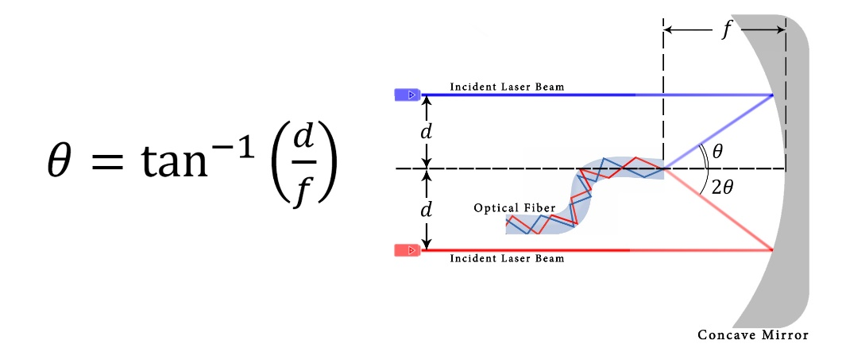

Fig. 4. By Elongating the Focal Point (f) and by Tightly Arraying the Laser Collimators (d), One Can Minimize the Laser Beam Incidence Angles, Thus Maximizing Coupling Efficiency

The setup shown in Fig. 5. was arranged on an optical breadboard. The plate and the mirror are installed on their own optical posts. The laser diodes that are housed in collimation tubes are powered and wired from the back of the plates, using SR9HB and SR9A connectors from Thorlabs. The plate and mirror are installed on a set of railings, allowing for the adjustment of the distance between the two. The entrance of the fiber is placed at the center of the plate, which allows for the capturing of eight reflected laser beams. The light guide then goes all the way to an optical rigid scope. Using holders, the optical rigid scope is oriented vertically. The specimen can be placed under the scope and be imaged. The rigid scope has a fiber input which allows for the light guide to be screwed on for the delivery of the laser light. All the movable parts of the apparatus have a set-screw. Thus, they can be fully locked into position. The following diagram illustrates how this apparatus couples the lasers.

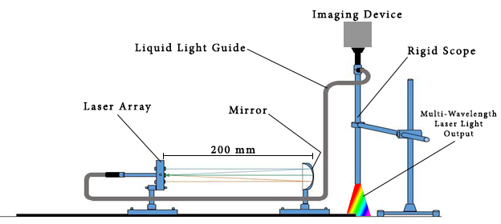

Fig. 5. The Laboratory Based Setup

Fig. 6. and Fig. 7. Represent the individual optical apparatus used in this project.

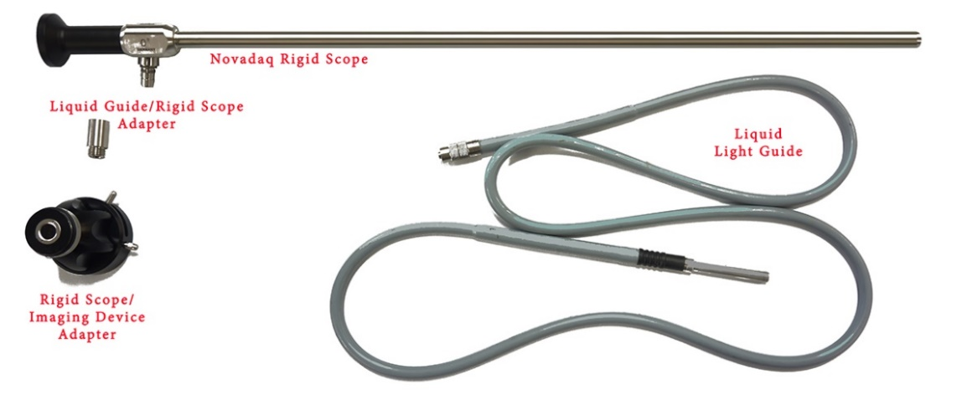

Fig. 6. The External Chassis Optical Components Used in the Project (Camera Not Included)

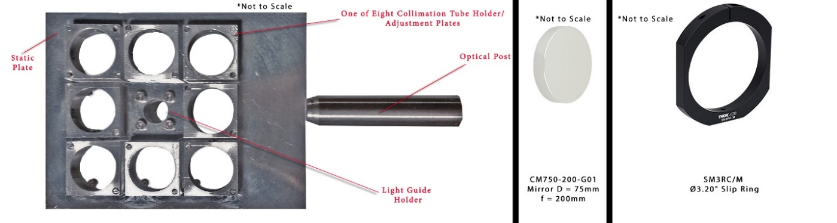

Fig. 7. The Internal Chassis Optical Components Used in the Project

Furthermore, the entire setup would then be miniaturized and compartmentalized, to fit inside the chassis that is outlined later in this report.

**I-c. Electronic Hardware Advancements**

The current project mainly focused on the electronic aspect of the project, where many functional units of the prototype were figured out. The following section lists these advances.

**I-c-a. Power Supply Design – Pre-regulation**

In Fig. 8, the power supply design is illustrated.

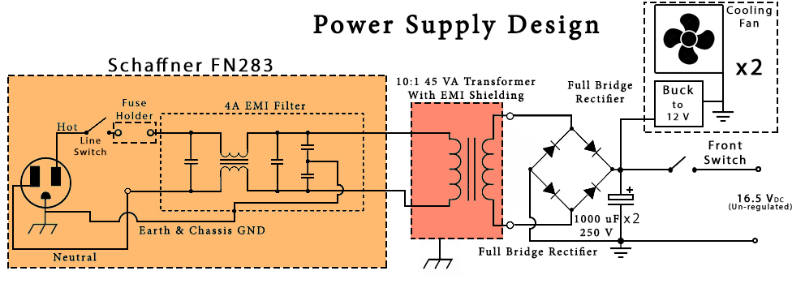

Fig. 8. The Power Supply the Mains Input is Stepped Down and Rectified to Yield 16.5 VDC

In the power supply, an all-in-one module (FN283) was used, to serve as a mains inlet, switch, fuse holder, and EMI filter. The mains input is conducted, and low-pass fileted in this module and is then applied across the primary input of a step-down transformer. The output of the transformer is rectified and led across two 1000 micro-Farad capacitors. This would yield a yet un-regulated 16.5 VDC output. This output should be then regulated in further stages [3].

**I-c-a. Power Supply Design – Post-regulation**

Several linear regulators are used to step-down and regulate the 16.5 VDC un-regulated voltage rail. Four units of LT3081 regulator was used to step-down the un-regulated voltage rail to the respective 5, 5, 9, 10 VDC rails. The LT3081’s output voltage can be adjusted using a single external resistor. Fig. 9 illustrates the wiring diagram and set resistor values for these regulators.

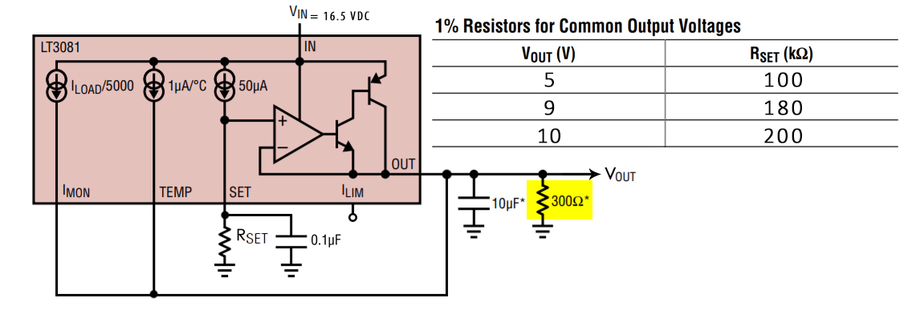

Fig. 9. LT3081 Wiring Diagram and Its Required Set Resistor Values for Desired Output Voltages

The four LT3081s would directly feed the WLD3343 and MLD203P1E laser drivers. All MLD203P1E (5 units) require 5 VDC for operation. Two LT3081 regulators, outputting 5 VDC were allocated to feed the MLD203P1E regulators. The WLD3343s require different voltages for their respective laser diodes. One needs 5 VDC, which gets that from one of the LT3081s, supplying the MLD203P1Es. The other two WLD3343s require 9 and 10 volts respectively. To satisfy this, each gets its own LT3081 regulator [4]. The laser drivers will be later discussed.

We are still required to have a 3.3 VDC to power the ADC, the laser power DAC, and the user I/O. A LM1086CS-3.3 was used to step-down the 16.5 VDC, down to 3.3 VDC. A 12 VDC rail is required for the relay coils. A uA7812 linear regulator is utilized to satisfy this requirement. A 5 VDC rail is needed to drive the LCD and the MCU, which is supplied by a uA7805. Fig. 10 illustrates the general wiring of these regulator [5], [6], [7].

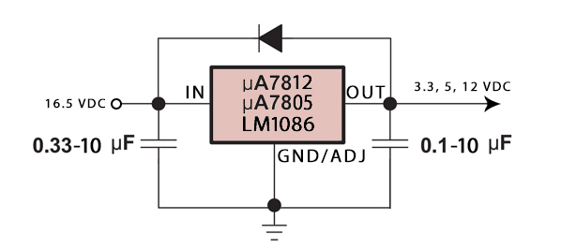

Fig. 10. The General Wiring of the LM1086, µA7805, and µA7812 Regulators

Fig. 11 Summarizes the Wiring of the Regulated Power Stage.

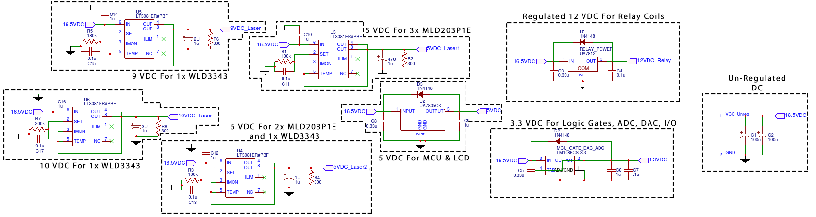

Fig. 11. Full Wiring Schematic of the Regulating Power Stage

**I-c-c. Laser Drivers**

As mentioned in the previous section the MLD203P1E and WLD3343 laser drivers are used to drive the lasers. Each driver needs to be configured to suit the laser diode it is driving. Fig. 12 and Fig. 13 outline the wiring schematic of the two drivers.

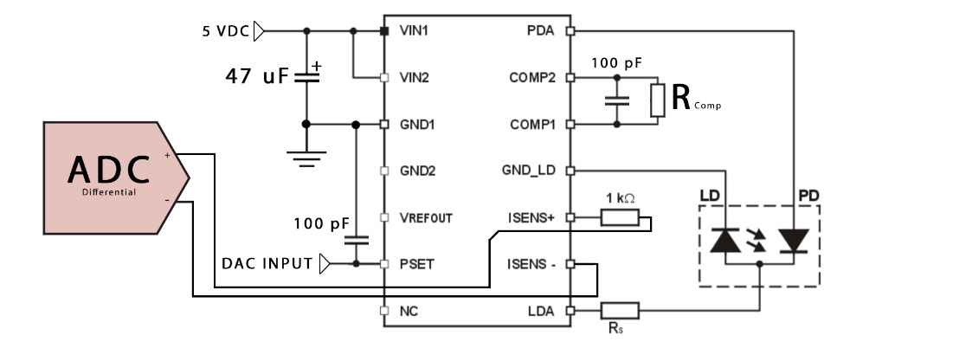

Fig. 12. Schematic of the MLD203P1E Laser Driver

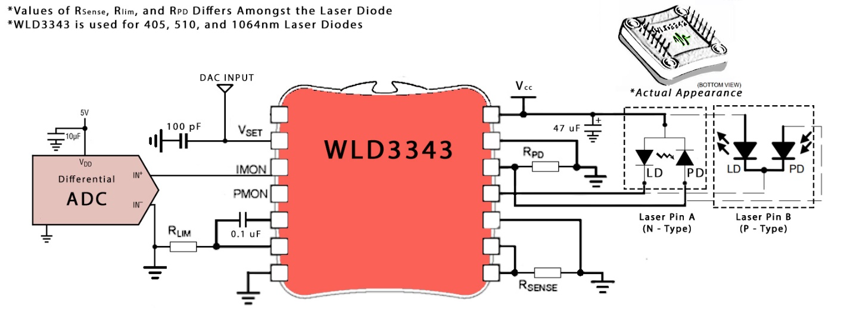

Fig. 13. WLD3343 Laser Driver Schematic

The MLD203P1E requires the calculation of Rcomp and Rs, to suit its laser diode. The WLD3343 requires RLIM, RSENSE, and RPD calculated resistors to suit its laser diode. It also requires different wirings of the diode depending on the type of laser pin type (Type A vs. Type B). Table 2. outlines the values for these resistors for each laser driver, paired with its laser diode.

Table 2. All the Laser-Diode-Specific Laser Driver Resistor Values

|  |  |  |  |
| --- | --- | --- | --- |
| MLD203P1E | | | |
| Laser Wavelength (nm) | **RCOMP (kΩ)** | **RS (Ω)** | |
| 640 | 4.00 | 7.87 | |
| 660 | 4.00 | 5.60 | |
| 670 | 4.00 | 14.0 | |
| 780 | 3.16 | 13.3 | |
| 830 | 4.00 | 16.2 | |
| WLD3343 | | | |
| Laser Wavelength (nm) | **RLIM (Ω)** | **RSENSE (Ω)** | **RPD (kΩ)** |
| 405 | 480 | 12.5 | 1.00 |
| 520 | 510 | 8.3 | 11.3 |
| 1064 | 576 | `5.2 | 3.30 |

The analog-to-digital converters outlined in Fig. 12 and 13 are related to laser diode current monitoring, which will be later discussed.

**I-c-d. Laser Power Control**

The light output from the light guide is slightly fringed, while the light output from the rigid scope is very fringed. The following images were taken using an imaging device mounted on the rigid scope. The Image demonstrates this fringing pattern that is observed at the output of the rigid scope.

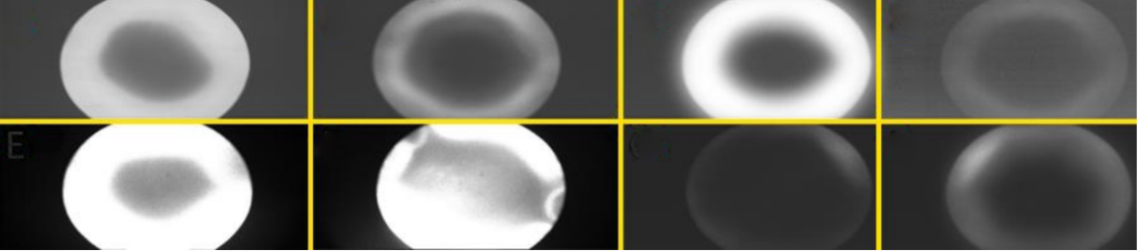

Fig. 5. Fringed Output Observed at the Rigid Scope’s Output

One reason for this problem is speculated to be interference in which light waves are superimposed and create a resultant wave with a different output distribution. In this case the light output has a destructive center and a constructive surrounding. Thus, the outside ring becomes bright and the center becomes darker. But the most probable speculation is that the modes of light that propagate through many internal reflections in the fiber make it through, while the modes that are supposed to take a mire direct path are lost/attenuated in the fiber.

Unfortunately, the experimental beam characteristics of out laser diodes are not yet known. We are currently designing new proper drivers for these lasers. All the information that is currently known about the lasers are in their datasheets included above.

The laser array plate was custom designed and machined out of Aluminum. For precise pitch and yaw rotation of the laser tubes, four screws were implemented for each laser tube. By fine adjusting these screws, one can ensure the desirable independent incidence of each laser beam.

The following image demonstrates a rendering of the laser tubes placed into the new custom machined laser array plate.

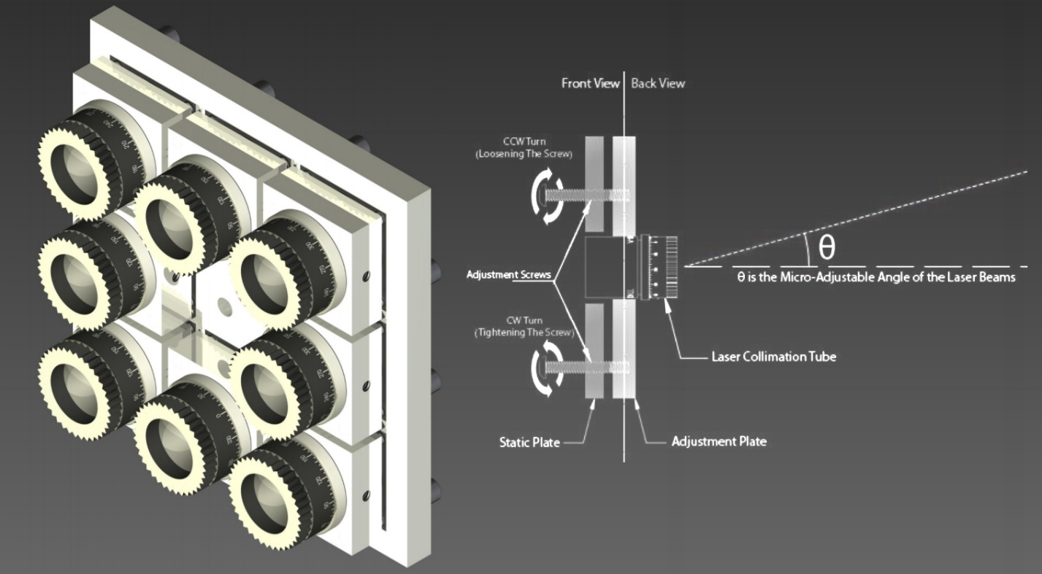

Fig. 6. Rendering of the Laser Array Plate and the Functional Diagram of the Adjustment Screws

The diagrams outlined in the Appendix section illustrate the dimensions and attributes of the laser array plate.

**3. Challenges Faced**

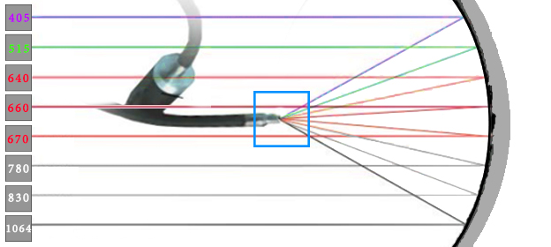

Fig. 7. Possible Location to Place Corrective Micro-Optics

We are very open to new suggestions and ideas regarding the ways this problem can be fixed. To recap, the problem is that we are getting fringed/ring shaped aberrations at the outputs of the liquid light guide and the rigid scope. Our idea consists of placing corrective optics either at the entrance or at the exiting point of the liquid light guide (where the liquid light guide couples with the rigid scopes entrance). Though, due to our lack of knowledge in advanced optics we don’t know how to act accordingly. If you had any further questions, please inform us through email and we will respond as soon as possible.

**4. References**

[1] Thorlabs Corporation. Introduction to Fiber Optics. Retrieved September 3, 2017. Available: https://www.thorlabs.com/newgrouppage9.cfm?objectgroup_id=949

[2] Newport Optics Corporation. Fiber Optics Basics. Retrieved September 3, 2017. Available: https://www.newport.com/t/fiber-optic-basics

[3] Schaffner FN283. Available: https://www.schaffner.com/fileadmin/media/products/pim/ DS_FN280_Korr_low_02.pdf

[4] Linear Technology. LT3081 Datasheet. Available: http://cds.linear.com/docs/en/datasheet/3081 fc.pdf

[5]

**5. Acknowledgements**

**4. Appendix**

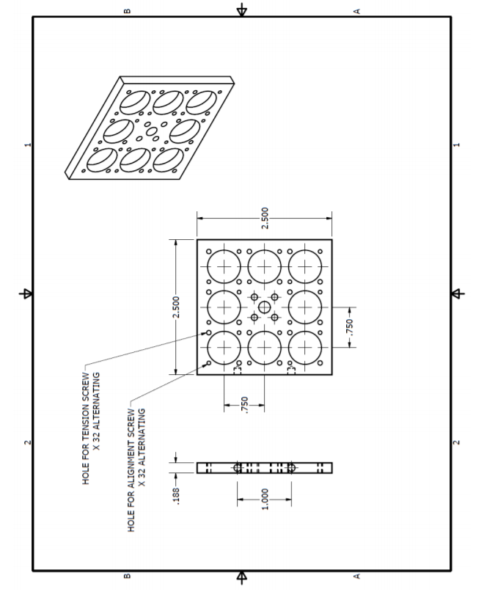

Fig. 8. The Static Part of the Laser Array

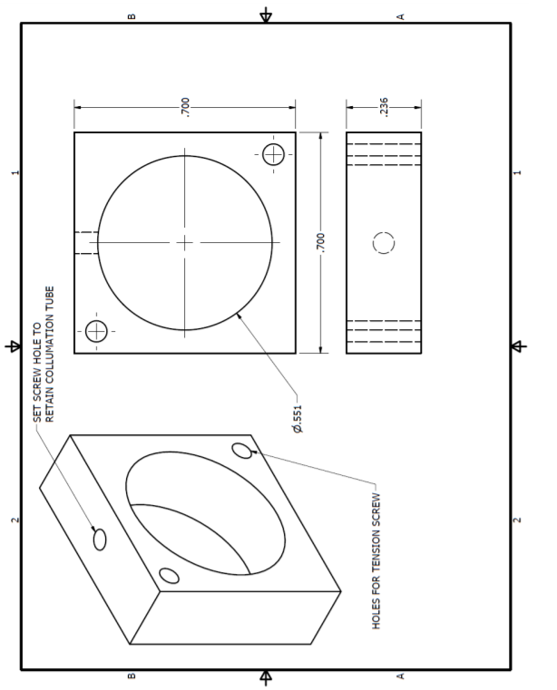

Fig. 9. Eight Identical Pieces of This Part Tightly Hold Each Laser Tube and Each Move Relative to the Static Plate, Allowing for the Fine Adjustment of the Laser Tube’s Pitch and Yaw Spatial Rotations Through the Turning of Two Tension and Two Back Push Screws, on the Static Plate

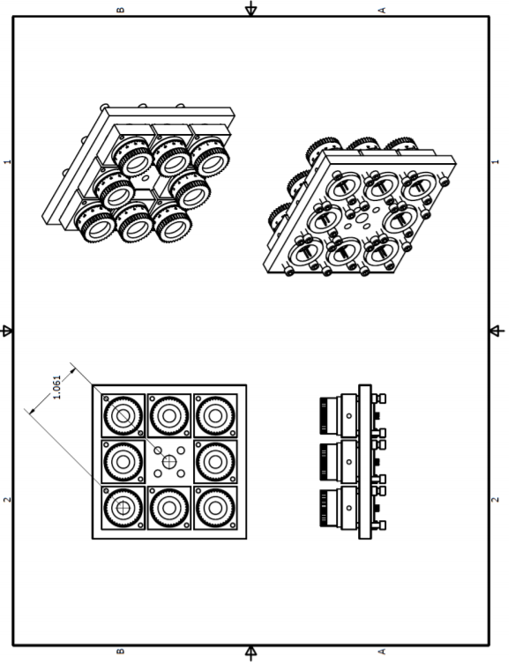

Fig. 9. The Rendering of the Fully Assembled Laser Tube Array, Containing the Thorlabs Laser Tubes